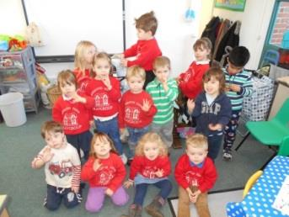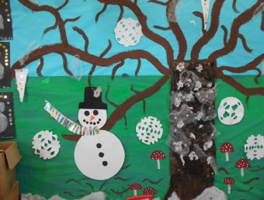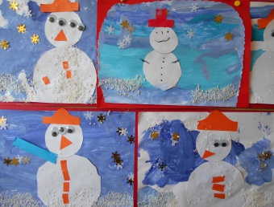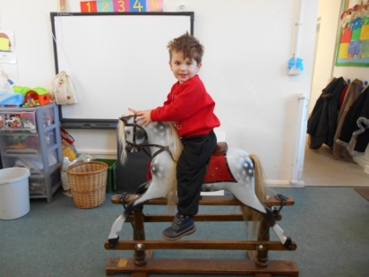

We also said Bon Voyage to the lovely Fintan who has begun a new adventure with his mummy and daddy in America. We send the family our warmest wishes and Fintan will be very much missed at Playgroup!

CLASS of 2014!
This term the Children have jumped straight in to Playgroup life and have got up to more than you can shake a stick at! This terms topic has been’ Winter’ and the Children have made some incredible wintery crafts, have been taking winter walks to our village Church and Robin spotting!

The Children have been celebrating Chinese New Year and have learnt about the Year of the Horse, made lanterns, sat and watched the Year 1 Chinese New Year Assembly in big School for over an hour beautifully, and tried Jennys amazing Chinese feast food. The topic for next term will be ‘OUTER SPACE’so keep in mind if reading books or visiting exciting places during Half Term!
A few housekeeping notes – Please remember to bring named wellies to Playgroup with your child each day – we go out to play come rain or shine!!
PLAYGROUP SWEATERS - Speak to Jenny, Lisa or Mavis or you wish to purchase one of our very stylish Playgroup Sweaters. These will be needed for the rising 5’s who will be going into school for lunch in the Summer Term.
A big THANK YOU to Michelle Wishart and Shannon Hind who stepped in to help Jenny and Lisa while Mavis has been away from Playgroup. You’ve been an enormous help and the children have loved having you to play! Jenny & Lisa – wow your amazing, what would we do without you!
For those of you who have not already done so, do remember to hand in your Allocation Forms for next Term and payment of Playgroup invoices are to be settled by the 12th Feb – Wednesday.
Dates for your Diary:
VALENTINE CAKE SALE – Midday Tues 11th Feb – Outside Playgroup.
PARENT & COMMITTEE MEETING – 8pm Wed 12th Feb – Bull Pub Burrough Green – please come!
HALF TERM DATES – Playgroup closes pm Fri 14th Feb – reopens Mon 24th February.

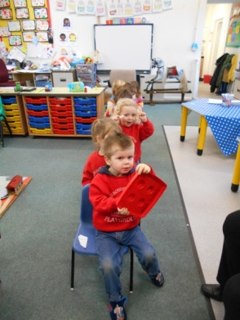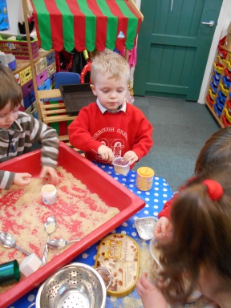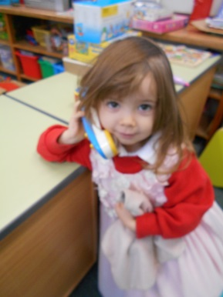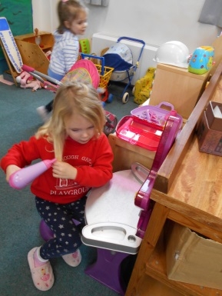
The girls have been especially busy!!
What a big train!

